Writing Vocabulary

✍️ What is Writing Vocabulary
# Source: AI Source: Provided by: [Data Path: Persons Table -> ID Column: 1, Name_En Column: Motasem Essam] -> From: [Chatgpt (GPT-4-turbo)] on [7/30/2025]
Writing vocabulary includes the words you can recall and use accurately in written communication. This vocabulary is often more precise and structured than speaking vocabulary, as writing allows more time for word selection and revision.

✅ Key Features:
# Source: AI Source: Provided by: [Data Path: Persons Table -> ID Column: 1, Name_En Column: Motasem Essam] -> From: [Chatgpt (GPT-4-turbo)] on [7/30/2025]
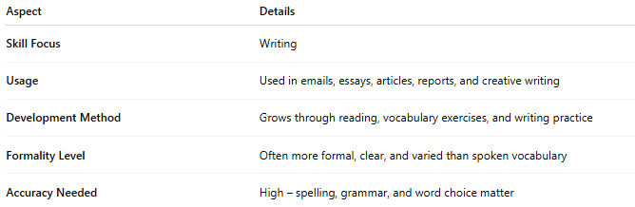
Aspect | Details
Skill Focus | Writing
Usage | Used in emails, essays, articles, reports, and creative writing
Development Method | Grows through reading, vocabulary exercises, and writing practice
Formality Level | Often more formal, clear, and varied than spoken vocabulary
Accuracy Needed | High – spelling, grammar, and word choice matter

🧠 Example:
# Source: AI Source: Provided by: [Data Path: Persons Table -> ID Column: 1, Name_En Column: Motasem Essam] -> From: [Chatgpt (GPT-4-turbo)] on [7/30/2025]
- You write: “The results were inconclusive due to insufficient data.”
👉 You actively use precise academic vocabulary like “inconclusive” and “insufficient.”

👤 Who Uses It?
# Source: AI Source: Provided by: [Data Path: Persons Table -> ID Column: 1, Name_En Column: Motasem Essam] -> From: [Chatgpt (GPT-4-turbo)] on [7/30/2025]
- Everyone who writes, especially:
  - Students in academic writing
  - Writers (creative or professional)
  - Professionals preparing reports or emails
  - Language learners developing composition skills

📌 Related Vocabulary Types:
# Source: AI Source: Provided by: [Data Path: Persons Table -> ID Column: 1, Name_En Column: Motasem Essam] -> From: [Chatgpt (GPT-4-turbo)] on [7/30/2025]
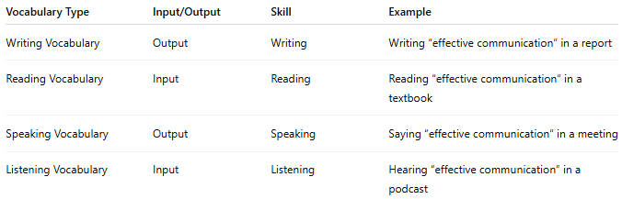
Vocabulary Type | Input/Output | Skill | Example
Writing Vocabulary | Output | Writing | Writing “effective communication” in a report
Reading Vocabulary | Input | Reading | Reading “effective communication” in a textbook
Speaking Vocabulary | Output | Speaking | Saying “effective communication” in a meeting
Listening Vocabulary | Input | Listening | Hearing “effective communication” in a podcast

